**Worksheet**

**EXPERIMENT – 6**

***Yash Gupta***

***20BCS5009***

# Aim:

Create an artificial intelligence powered ChatBot to mimic human interactions for e-commerce.

# Requirements:

PC with internet connectivity, Python 3.7

# Expected Outcome:

* *List down all the commands used*
* *Paste step by step screenshots*

# Output:

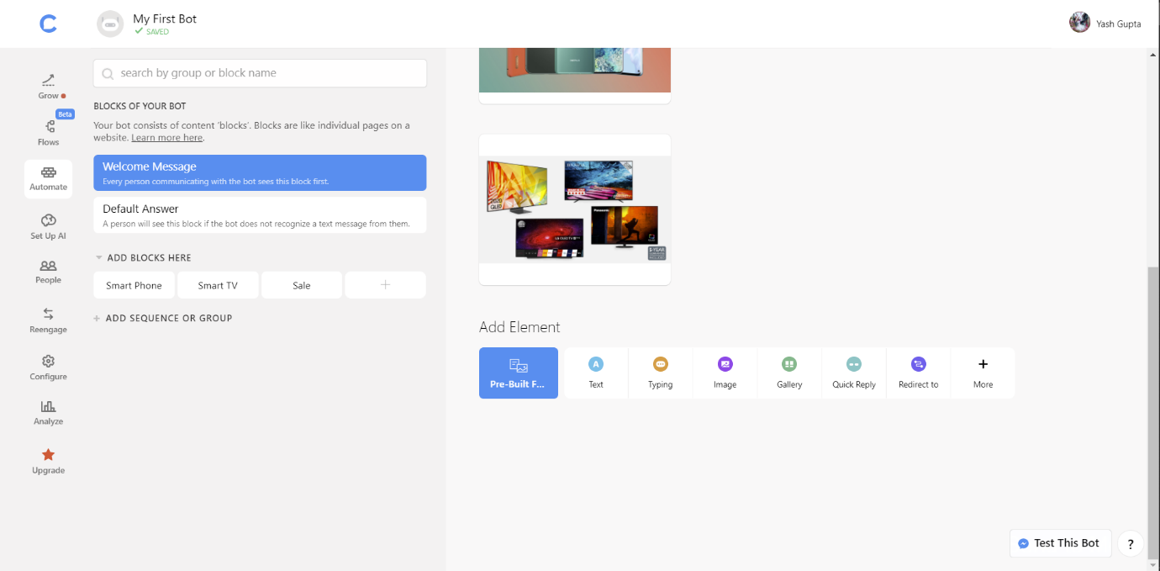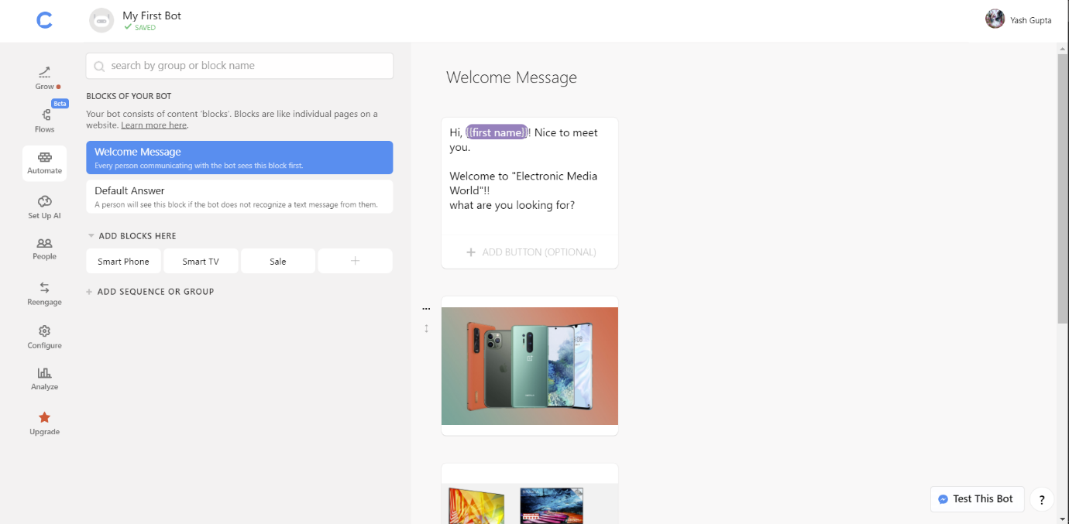 ***First page 🡪***

`

***Chatbot not responding 🡪***

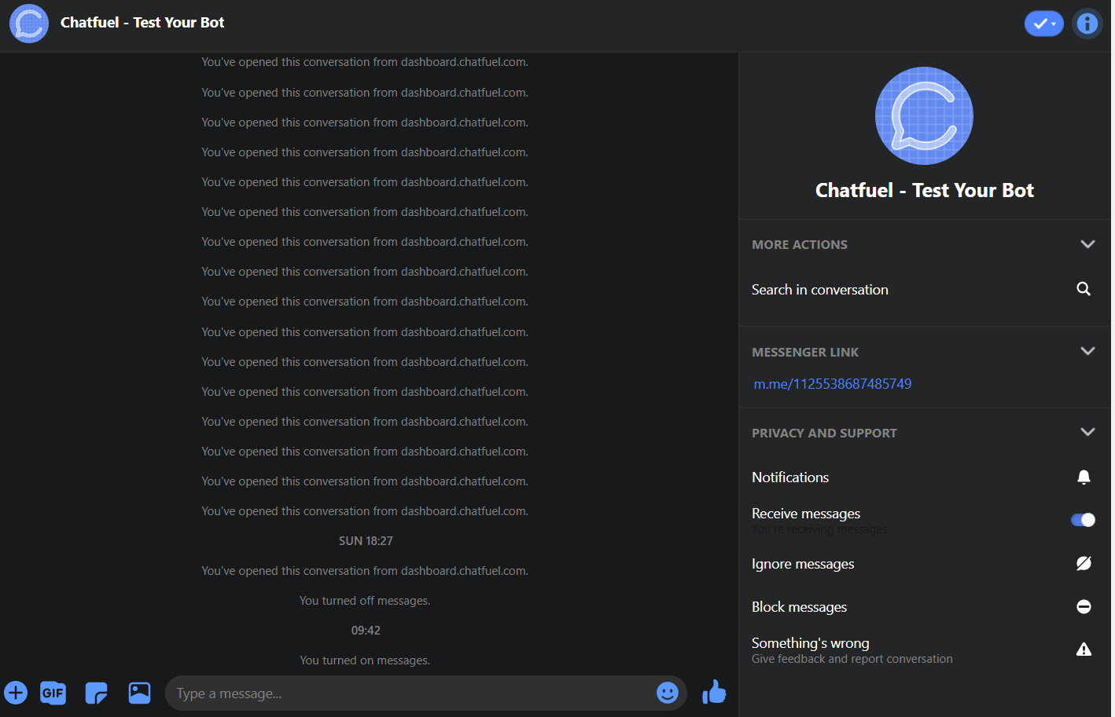

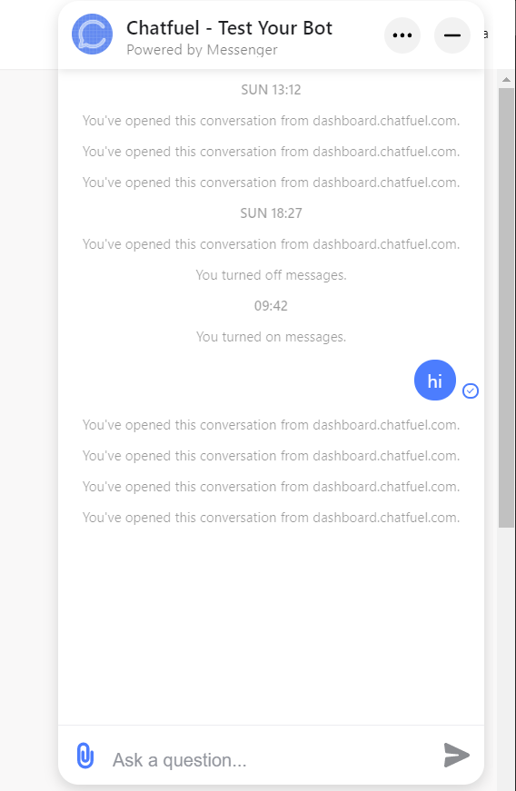

*If the user choose smartphone 🡪*

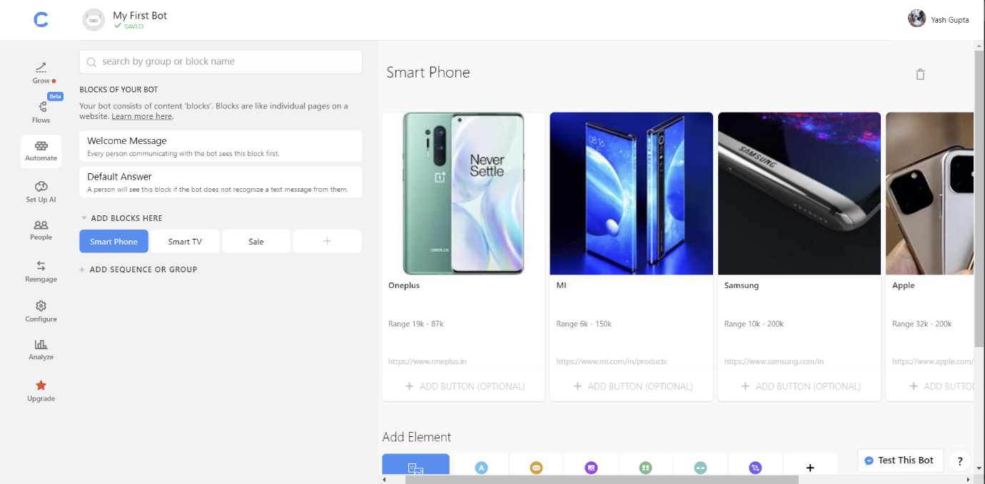*If the user choose tv 🡪*

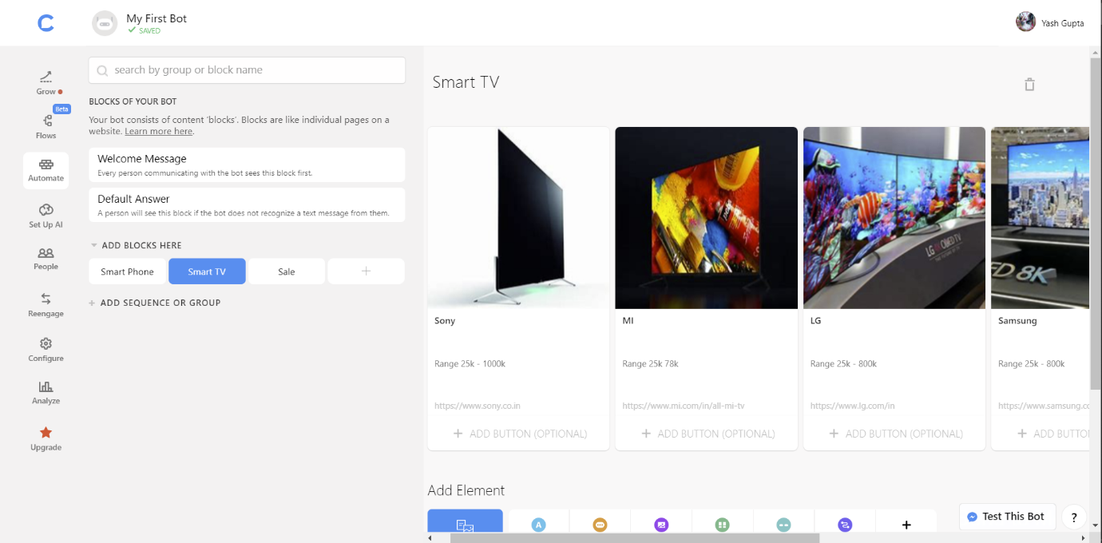

*If the user wants to know about sale*🡪

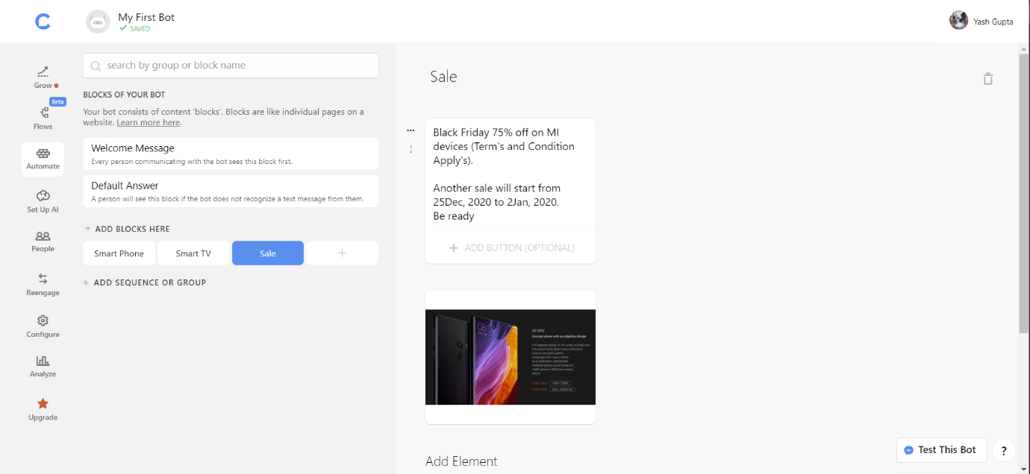

*My arrangement in AI* 🡪

